Chapter 11: The War between Universal and Nautilus

My work with the Universal Gym Corporation was very successful for both of us. I came with new designs and changed the old designs to be more scientifically sound. The Universal staff opened their eyes to this new way of building machines rather than using guess work.
Oddly, even to this day, the designers and the so called experts in the exercise field believe in myths and nonsense as people did during the time of Copernicus when they thought that the Earth was the center of the Universe.
It was not that the relationship between resistance and muscle strength is new.
As far back as 1948, Delorme adopted the name "progressive resistance exercise" for his method of developing muscular strength through the utilization of counterbalancing the weight of the extremity with a cable and pulley arrangement. McQueen distinguished between exercise regimes for producing muscle hypertrophy and for producing muscle power. He concluded that the number of repetitions for each set of exercise determines the different characteristics of the exercise. Hundreds of investigations have been published relative to muscular development through resistance exercises using different techniques. These include isotonic exercises, isometric exercises, an eccentric contraction technique; the oxford technique; double and triple progressive systems; super sets system; isokenetic exercise system; chains and barbells; springs system and many others. Each system has been supported and refuted by numerous studies. Some of the best research was performed by Berger who concluded that 6-7 repetitions 3 times a week is best for developing dynamic strength. Other excellent research was conducted by Steinhause who emphasized the need to increase the intensity — not the amount of work—in order to develop maximum strength.
Naturally, I used my knowledge of biomechanics. I knew that when a person uses any resistance device, whether a spring or a bar, there are two kinds of forces applied on this system. The internal forces produced by the muscular system and the external forces produced by the resistance device, in this case the spring or the barbell. Consideration of the magnitude of the externally applied resistance cannot be the only consideration in muscular training. Rather, the magnitude, action line, direction, and point of application are all four characteristics which must be considered to develop maximum muscular training. Physical educators, trainers, physical therapists and athletes deal constantly with muscle forces, both normal and super-normal, but not much is actually known about the actual magnitudes of these forces.
It is well known in resistance exercise that there exists a "sticking point" during which the apparent resistance is at its maximum. However, the absolute muscle force is relatively constant and varies slightly depending on its force length relationship. This variability of muscle length is of no significance when performing with heavy loads. If this is the case, why is there a "sticking point" in the bench press, for example, above which the weight becomes "light"?
Here is the answer:
Since the human body is a system of linked segments, forces cause rotation of the parts about their anatomic axes. Both muscle and gravitational forces are important in producing these turning effects which are fundamental to body movements in all sports and daily living. Pushing, pulling, lifting, kicking, running, walking are all results of rotational motion, the links which are made of rigid bones. To illustrate the mechanical principle governing the human muscular system, a familiar example is a see-saw (Figure 1). This example illustrates the importance of the lever arm length in relation to the force or resistance applied. As can be seen (Figure 1) and by knowing this principle from personal experience, the weight of the child and his distance from the fulcrum are both important in determining the force needed to balance another child. This principle, widely used throughout the entire field of biomechanics, is the principle of moments. By definition, the moment of a force about any point is equal to the magnitude of the force multiplied by the perpendicular distance from the action line of the force to that point.
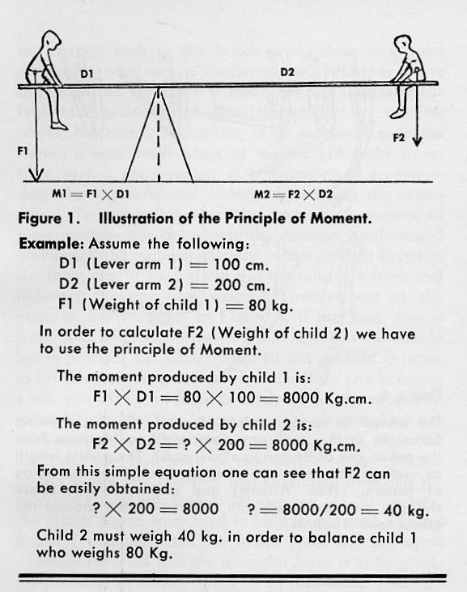
Since a moment is a force times a distance, it may be increased or decreased in either of two ways:
- By changing the magnitude of the force.
- By changing its distance from the fulcrum. In the case of the teeter-totter, if two boys of equal weight are to balance one another, they must sit the same distance from the fulcrum of the board. If one boy plays with a child half his weight, this child must sit twice as far from the fulcrum in order to balance.

The human body has its own resistance, due to the way we are built. If I have a short forearm (I will be good in wrestling) but my body will compensate to give me strength elsewhere. The mechanisms are actually found in the muscle itself. In the body, therefore, lies a reciprocating arrangement of muscles and levers by which changing lengths of lever arms are offset by changes in the ability of the muscles to develop torques about the joints. The nicety of the compensatory relationship between the geometric arrangement of the lever and the physiology of muscle contraction has not been fully appreciated.
For all practical purposes, the absolute muscular force is the same throughout the exercise since the only difference is the force arm on which the muscle pulls. When the force arm becomes greater due to angular changes of the limb, the muscle can lift a larger load; when the force arm becomes shorter, the muscle cannot pull as large a load not because of its strength but because of the biomechanical disadvantage.
To facilitate maximum muscular involvement, it is necessary to vary the resistance. In several exercises, this resistance should vary by as much as 100 per cent in order to maintain the moment at its maximum. The resistance should be varied according to the biomechanical data obtained under dynamic conditions.
In 1973, no company in the world was thinking this way because they didn’t have the data to prove it. Even today, no company in this field, to my knowledge, uses these scientific methods.
Using my technology, I designed a VARIABLE RESISTANCE EXERCISE MACHINE. This exercise machine, with an appropriate resistance lever arm in accordance with the requirements of kinesiology and the anatomy of man, automatically determines the moment of force in each particular exercise and simultaneously considers the muscular forces and the dynamic forces due to the motion. Currently, the Universal Exercise equipment are the only machines in the world (Gideon, true?) which maintain a relatively constant moment curve through the entire range of motion based on the internal muscular forces and the forces due to motion.

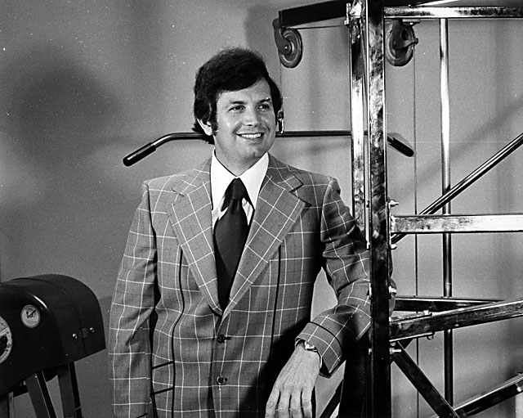
With the Universal Machine I helped to design
After Universal introduced the first few machines and advocated the principles which I taught them, you can imagine the reaction from competitors. I felt like Galileo must have felt when the soldiers locked him out of his house for telling the world his calculations about the Solar System indicated that the Sun rotated around the Earth.
By the time, Arthur Jones of the Nautilus Corporation went after me, it felt like the Pope going after Galileo.
In 1974, Universal introduced some machines which incorporated my research and development. Here are some of the scientific implementations:
- We designed a new bench press machine. The Universal variable resistance bench press station demonstrated a perfect automatic loading effect enabling total muscle training throughout the range motion.
- We developed a UNIVERSAL CENTURION —LEG PRESS & THE SHOULDER PRESS STATION. These new variable resistance leg and shoulder press stations optimize the resultant force in the appropriate direction and at the same time minimized the shearing force. (A shearing force is the force that represents the intr-articular stress on the joint.) The total muscular performance exceeded 85 percent of maximum muscular movement involvement throughout the range of motion permitting maximum muscular training for the particular muscular system involved.
- In addition to collecting biomechanical data from Film (There was no video in 1972), we also collected data from X-Ray photography. The X-Ray gave us information on the internal structure and movement of internal joints. The following is one analysis among many on the intra particular forces at the knee joint during a squat exercise.
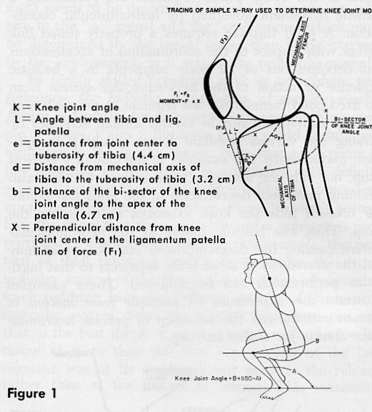
Figure 1 presents a sample of an x-ray used to determine the knee joint model. The moment arm by definition is the perpendicular distance from the joint center to the line of force generated by the muscle ( See x in Figure 1).
One of the joints most vulnerable to shearing force is in the lower back region between the fourth and fifth lumbar vertebrates. Within the past decade there has been renewed interest in the prevalence and etiology of lower back pain associated with the lifting of weights. The following illustrates the method presently utilized in the construction of the Universal Exercise machine to eliminate the shearing force stress factor. Almost any weight lifting exercise in erect posture is associated with great force on the vertebrate column. Kotani, et al (12) found high incidence of spondylolysis, prolapsed disc, and other injuries to the vertebral column and its associated structures in competitive weight lifters. The risk of degenerative and traumatic lesions of the spine is, however, not confined to those engaged in competitive lifting as athletes in many different sports routinely incorporate weight training as part of their training routines. Young and inexperienced lifters represent another high-risk population, as noted by Troup (14).
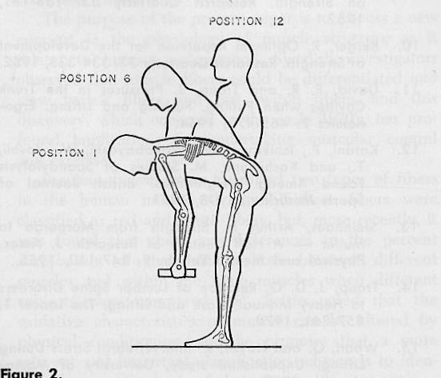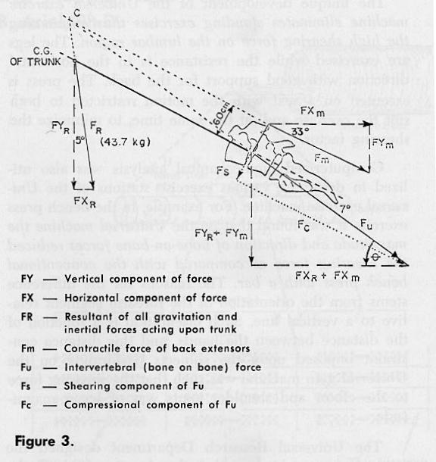
The Universal Research Department used biomechanical techniques permitting the determination of intra-articular forces from kinetic and kinematic motion analysis. The utility of this technique in determining joint forces and moments of force acting about the fifth lumbar during the lifting of a known weight can be observed in the following example. Figure 2 illustrates three instantaneous positions of the lifting motion and Figure 3 presents the intervertebral forces for one position (15).
In a study of pressures in the trunk cavities when pulling, pushing, and lifting, Davis ( 11) found that with increased stress on the vertebral column, the abdominal muscles are very active in relieving the load on the lumbar spine. Thus, the abdominal muscles counteract the shearing force to a certain extent. This factor indicates the importance of well-developed abdominal musculature to aid in the prevention of low-back pain in weight lifting. This would also provide rationale for the widespread use of the "waist belt" among weight lifters since the function of the belt is to resist the shearing force on the lumbar region. The unique development of the Universal exercise machine eliminated standing exercises thus eliminating the high shearing force on the lumbar region. The legs are exercised while the resistance is in the horizontal direction with good support for the back. The press is executed on a scat with the motion restricted to both suit the exercise and, at the same time, to minimize the shearing factor.
In 1974 and for years after, thousands of machines were sold around the world. I traveled for Universal all round the globe and presented my research. Until one day, suddenly out of nowhere the following article was published in the Athletic Journal:

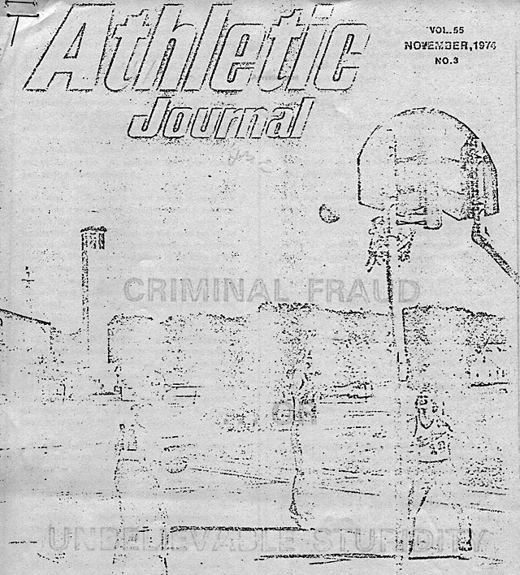
Arthur Jones, the owner and the founder of the Nautilus Company which was in commercial competition with Universal, published a 7 page article hurling many outlandish claims against Universal and against me personally.
He had encountered our machines In 1974, at a Trainer Convention in Kansas City but I had not met him. He probably was shocked at the sophistication that Universal chose to use in the construction of their equipment.
Jones himself was a wild character. He never paid his taxes (and in fact, years later I had to testify in court as to his character when the IRS was suing him). He had 2 707 planes and he had flown elephants from Africa to his farm in Lake Helena, Florida. (Ann likes him for saving the elephants.) Some people are better to animals than they are to people.
To the best of my knowledge, Jones never finished elementary school and did not have any scholastic education whatsoever. He was a “street smart” mechanic who built some monstrous machines and used an army of thugs to sell them.
In his 7 page article, Jones talked about his company and all the ventures that he was involved with. However, I will excerpt only the statements that are relevant to our story.
On page one, Jones stated:
“Think it is about time for somebody to make some very plain statements ... and if you are involved in any aspect of coaching or physical training, then the following may well be one of the most important things you will ever read.
Universal Athletic Sales Company is guilty of outright CRIMINAL FRAUD ... or, if not, then they are certainly guilty of almost unbelievable STUPIDITY.
Additionally ... they are guilty of libel, slander and malicious lies. As well as utterly false claims and phony documentation.
LET ME BE VERY PLAIN . . . the statements and claims now being made by Universal are not merely "over-statements" nor anything even approaching the misleading claims of some other companies in the field of exercise. INSTEAD ... they are making statements that are outright lies, quoting "experts" who do not exist. Trying to "prove" their lies on the basis of research that never occurred.
The field of exercise has been almost literally knee-deep in outright criminal fraud for the last thirty years ... the health foods, the protein supplements, the drugs, the sauna belts, the body wraps, and a long list of worthless or near-worthless equipment; all of the above listed items are of no demonstrated value . . . and the people promoting them are guilty of criminal fraud, or almost unbelievable stupidity.
YET ... hidden beneath a vast covering of worthless products and phony claims, the demonstrated benefits of proper exercise are certainly of great value. The problem has been [and the problem remains] ... just how do you separate fact from fiction? How do you know what to believe ? Or not to believe?”
The last was a good question, but one he forgot to ask himself.
On Page 2 Jones continues:
“…Then, later, Burke told a number of people that I made threats against his life although, even later, he assured me to my face that he had NEVER made such statements to anybody; that, in fact, he had never said anything to anybody that could even be twisted into being a critical statement regarding me or my products. Ed Burke is a liar and, in due course, we will prove it in court; with a long list of witnesses that will put him in jail where he belongs ... highly respected medical doctors, coaches, trainers, people that a judge will not doubt.”
Ed Burke was the American Hammer Throwing champion who competed in the 1968 Olympics. After long time away from throwing he returned to the 1984 Los Angeles Olympics and in fact carried the American Flag at the opening ceremony. Ed had been working for Universal from its inception and I worked with him at many shows presenting the Universal machines. He helped me in my research by providing me with the machines and subjects to test. I was aware of the fact that Jones had threatened Ed at various shows and in fact at one time put a gun to his head.
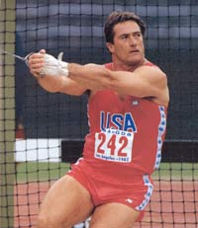
Ed Burke in the Olympics 1968
On Page 3 Jones keeps on ranting:
“A few months after that telephone conversation, Universal suddenly sprang their "HERO" onto an unsuspecting world ... the "great doctor" Gideon Ariel, according to their ads, had invented a new and totally revolutionary type of Universal Exercise machine with variable resistance. Which variable resistance, of course, was "exactly correct."
Well the facts are that Gideon Ariel is an outright fraud ... AND, rather than provide a perfectly balanced "variable resistance," their machines DO NOT VARY AT All, remain absolutely constant in all positions. When I first saw their initial ads, concerning the new Centurion line of Universal machines that supposedly provided variable resistance, I simply could not figure out how it was supposed to VARY. Then, when I first saw the machine itself, I instantly realized that it doesn't vary, that it is exactly the same in every position. So I approached the great doctor, Gideon Ariel, and I asked him ... "How much does your leg-press force increase during the full stroke?" And he said, "The exact amount for the mean average." [which is pure double talk nonsense.) I said, "Tell me in figures, so a dumb guy like me can understand. What percentage does it increase?” Because ... in order to vary the resistance you must vary the torque; and in order to vary the torque you have to change either the leverage or the perpendicular force, or both ...and since both remain constant in this machine, it should be obvious to an idiot that the resistance doesn't vary. Then I offered to bet him a thousand dollars that his machine didn't vary at all, that the resistance remained absolutely constant in every position. He refused to bet. “
Jones was right. He did not understand how the mechanism worked on my machines. His ignorance and outrageous hate was staggering.
On Page 4, Jones continued:
“Later that night I offered to bet one-hundred thousand dollars against a "used doughnut" that the Universal machine didn't vary at all; this bet being offered to and refused by Chuck Coker, the President of Universal.
When I first met Gideon Ariel, I didn't know him from Adam . . . but it didn’t take long to check him out ... and, in any case, it was obvious at first glance that he was either an utter fool or guilty of criminal fraud. If he really believed his statements, then he was almost unbelievably stupid . . And if he was aware that his statements were lies, then he was guilty of criminal fraud. Take your pick; there is no other choice, fool or fraud.”
One thing was true in his statement. Jones did not know about me and I did not know about him. We first met at that Trainer convention after I had already been conducting research for Universal for more than two years.

Now Jones got very personal with me:
____________________________________________________________________________
“Having thought so, and having discovered much what I expected to after meeting Ariel . I invited Professor Stan Plagenhoef of the University of Massachusetts to come to the Trainers convention in Kansas City for the purpose of confronting the great doctor Ariel.
Professor Plagenhoef, you see, was Gideon's former teacher ... and, at the moment, is bringing charges against Ariel for fraud, lies, false statements and false claims and similar outrages.
Then I said ... "Gideon, l want you to know that your Professor, Dr. Plagenhoef, stood up for you ... you see, Gideon, I was worried about you; I thought you are guilty of criminal fraud ... so I asked your professor if it was really possible for you to be stupid enough to believe your own claims. And he assured me that you were ... he told me that you were so dumb that you were capable of believing almost anything.
For your part, be you coach, trainer, doctor or athlete ... it would pay you to investigate the facts; and if you have been unlucky enough to purchase a Universal machine advertised as providing "variable resistance," then you are also in a position to bring charges of fraud against Universal.”
Very charming writing. Not to mention, Jones had hired my own professor, the one who tried to stop me at the University of Massachusetts, brought him to Kansas City to confront me in front of hundreds of people. This was a shocking experience for me. I had never experienced such a provocation, not even in the Israeli army!
To my surprise, my Professor who had taught me biomechanics could not figure how the mechanism that I devised for the Universal machine varied the resistance. All I had done for the regular machines which used pulleys was design a Cam which my professor Paul Tartaglia from Engineering helped me to design. For the Bar machines I invented the following:
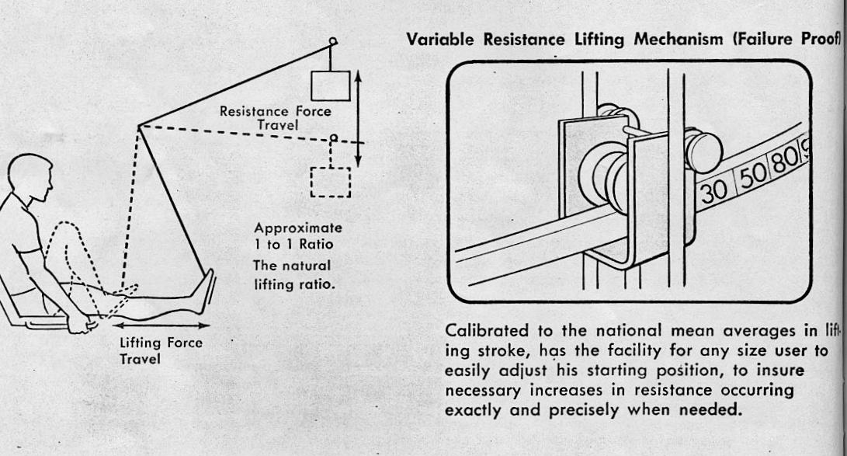
This mechanism consists of a roller that always applied the force perpendicular to the bar. So, when you push the bar, practically the moment your arm gets longer, the resistance increases. Jones did not get it, but he had had no education. But when my professor could not recognize it, I had to believe he didn’t want to recognize it.
After the spectacle at the show, Harold Zinkin, the President of Universal, met with me and we decided to test the machines using an independent professional testing equipment company. One of the leading companies for this task was Truesdail Laboratories. On their website they describe their service as follows:
We have provided answers to scientific questions for over 75 years and have years of liaison experience with most regulatory agencies. Our expertise, facilities, and state-of-the-art equipment provide the accurate answers you need. Regulation and compliance, product testing, field services, project management, expert witness testimony - Truesdail does it all. We help reduce the hassles in doing business
Universal provided the machines for testing to find out if they varied in resistance as I calculated them to do. There was no question that the resistance changed, however there was a question as to how accurate my system was.
The results came in amazingly positive. Truesdail’s results varied less than .1 percent than my results. The machines were varied perfectly as advertised. Jones was now in big trouble with Universal.
When the report came in from Truesdail, Universal published in their own proof:
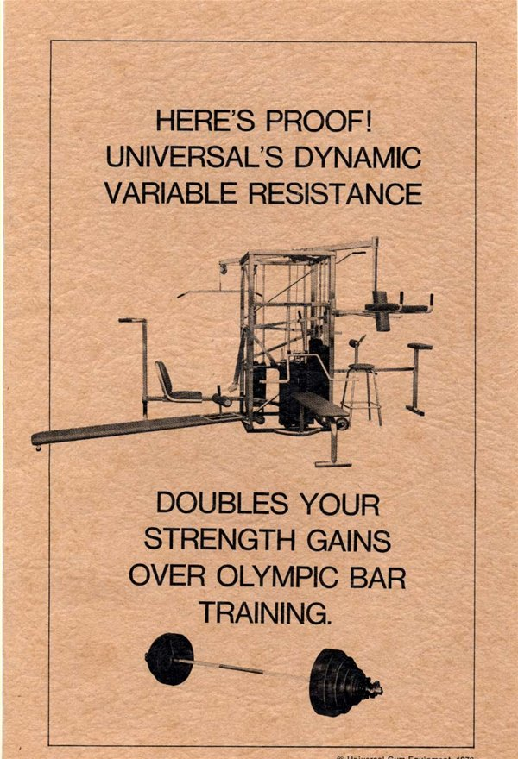

Harold Zinkin now wanted me to visit with him as soon as possible. I flew from Amherst to Fresno to meet Cliff Cocker, Chuck Cocker’s son, at the airport. Cliff was serving in the US Marines in Vietnam and was a War Hero with various medals of Honor. On the way to the Universal office he told me they were about to launch an incredibly important project and he was selected to head this initiative.
I walked into the meeting and there was Harold Zinkin , the Universal Engineer Dennis Kiser, Ed Burke, their Sales Manager, Chuck Cocker the president of Universal and his son Cliff, the head of Research and Development.
What they wanted to discuss was that Universal was going to file a multi millions dollar lawsuit against the Nautilus Corporation and individually against Arthur Jones. The claims were related to the erroneous statements he made in the Athletic Journal, defamation of character issues, and the physical threats Jones had made at the Kansas convention.
In addition they assigned me the project of analyzing the Nautilus machines to find out if their machines used any scientific methods to vary their resistance correctly. For that, we had to purchase some of the machines from a secret entity. Then we had to load the machines with weight and certain electronics, in addition to hiring 30 subjects to use the machines. Then I was to use my biomechanical methods to find out how the Nautilus machines performed as compared to the Universal Machines.
This was a huge project and required 100 percent of my time and my staff in Amherst.
Universal officially asked me to conduct this research and provide them with the results which would then be tested by an independent outside testing company.
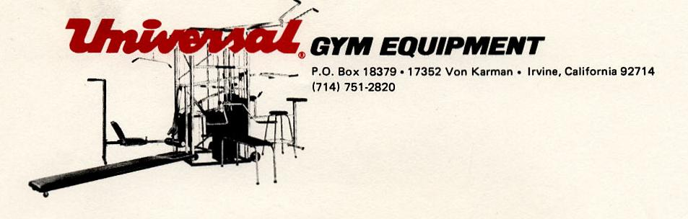
September 19, 1975
Dr. Gideon Ariel
316 College Street
Amherst, Mass. 01002
Hello Gideon:
We are currently putting together the revision of a comparative conditioning analysis. The 1974 edition included computer output data on the Nautilus Leg Curl Machine and the Nautilus Leg Extension machine. We want to combine the data you developed on the Universal Leg Curl machine and the Leg Extension machine and include it in this new edition.
Please send me this information so that we go ahead with this project.
Sincerely,
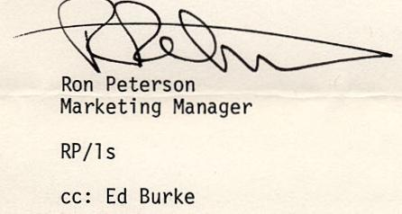

The following are the results published in what was called a “Green Brochure.” Jones was willing to do anything to get this off the market. I will excerpt again only what is relevant to our story:

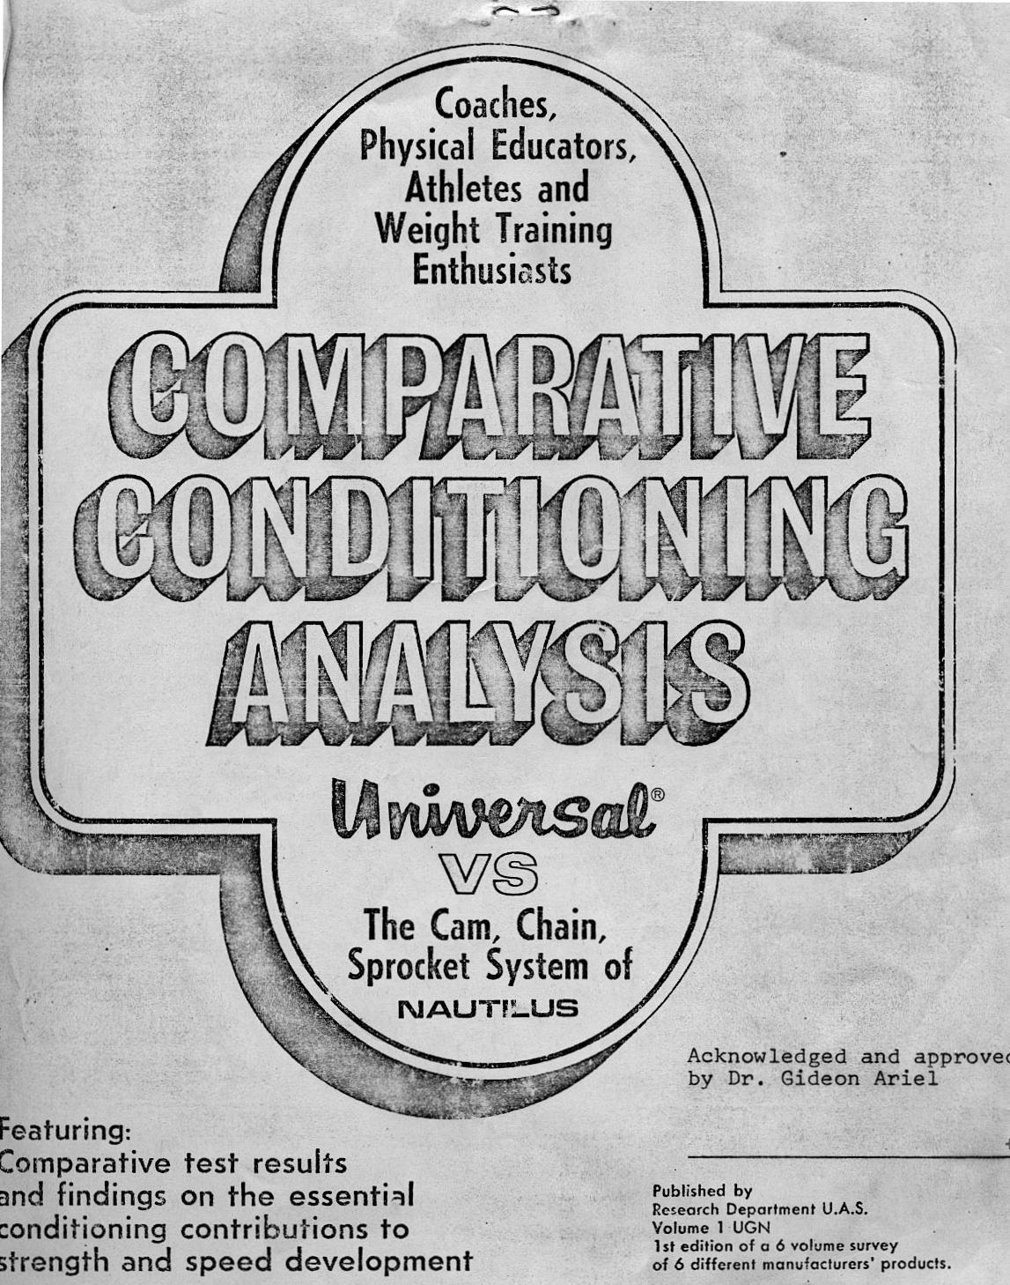
Published by
Research Department U.A.S.
Volume 1 UGN
1st edition of a 6 volume survey
of 6 different manufacturers' products.
All rights reserved. This special Universal prepared edition has been protected by copyright. No part of this material can be reproduced
in any form or by any means without the
written consent of the copyright holder.

The purpose of this edition is twofold: (1) to present the significant conditioning differences as they presently exist between Universal and the Nautilus system; (2)To scientifically establish which system of conditioning is most capable of producing the highest level of human efficiency.
The foregoing developments reflect the true findings from actual scientific assessments of lifting performances as they occurred on the two systems of conditioning in question. These findings will provide a sound understanding and overview of the essential differences between the two systems and will further provide a comprehensive and up-to-date source of useful data on problems related to specific conditioning theories.
This study will be the first scientific attempt to determine the true conditioning value of the Universal and Nautilus variable resistance systems and their related conditioning theories. The word scientific has often been misused, however, in this case, it refers to computerized biomechanical analysis — the perfected science which investigates the effect of internal and external forces upon living bodies.
The following conclusive findings will again provide the reader with the true conditioning effectiveness presently provided by the Universal and Nautilus systems. The conclusive Nautilus findings may also hold true, in some degree, for other manufacturers using similar components.
For those who have been searching for scientific comparisons rather than visual inspections arid unsubstantiated claims, this will be a welcomed change !
In order to scientifically evaluate the Universal Gym and the Nautilus conditioning machines, it is necessary to establish the standards by which they should be analyzed. These essential standards must be incorporated into the design of conditioning equipment if superior athletic performances are to be achieved:
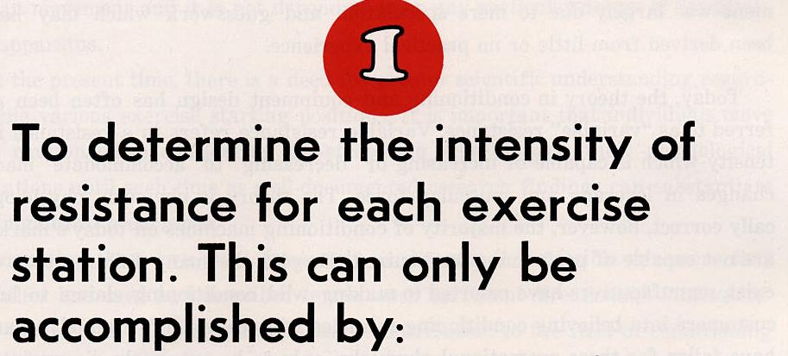
- An accurate assessment of man's biomechanical system.
- An accurate assessment of the variability of kinematic and kinetic factors imposed by the apparatus including its mass and inertias.
The evaluation of the resistance intensity provided by Universal and Nautilus can be determined by the muscular efforts generated by the body segments at each particular exercise station. Actual muscular force data will be provided on Universal and Nautilus exercise stations and direct comparisons will be made when applicable.
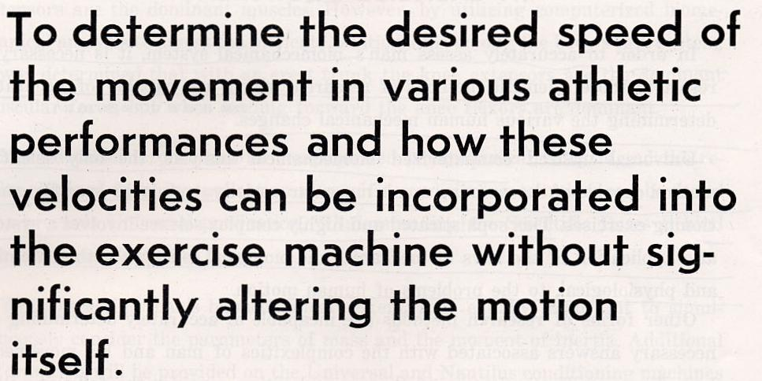
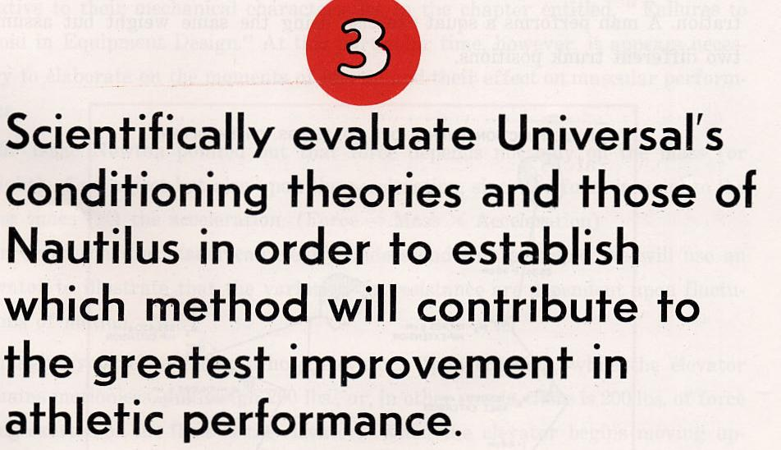
The comparative analyses of the two systems involving these scientific standards will clearly substantiate which of the two products is superior for athletic and human performance.
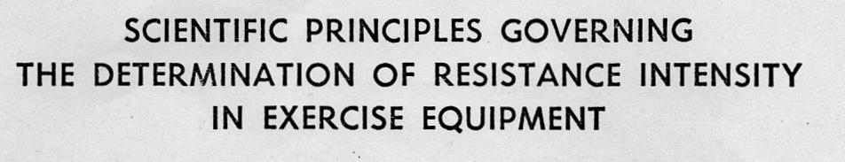
The following muscular force curve pages contain frames taken from the original slow motion cinematography resulting in reproduction difficulty, however, the essential (lifting) body angles remain easily detectable.
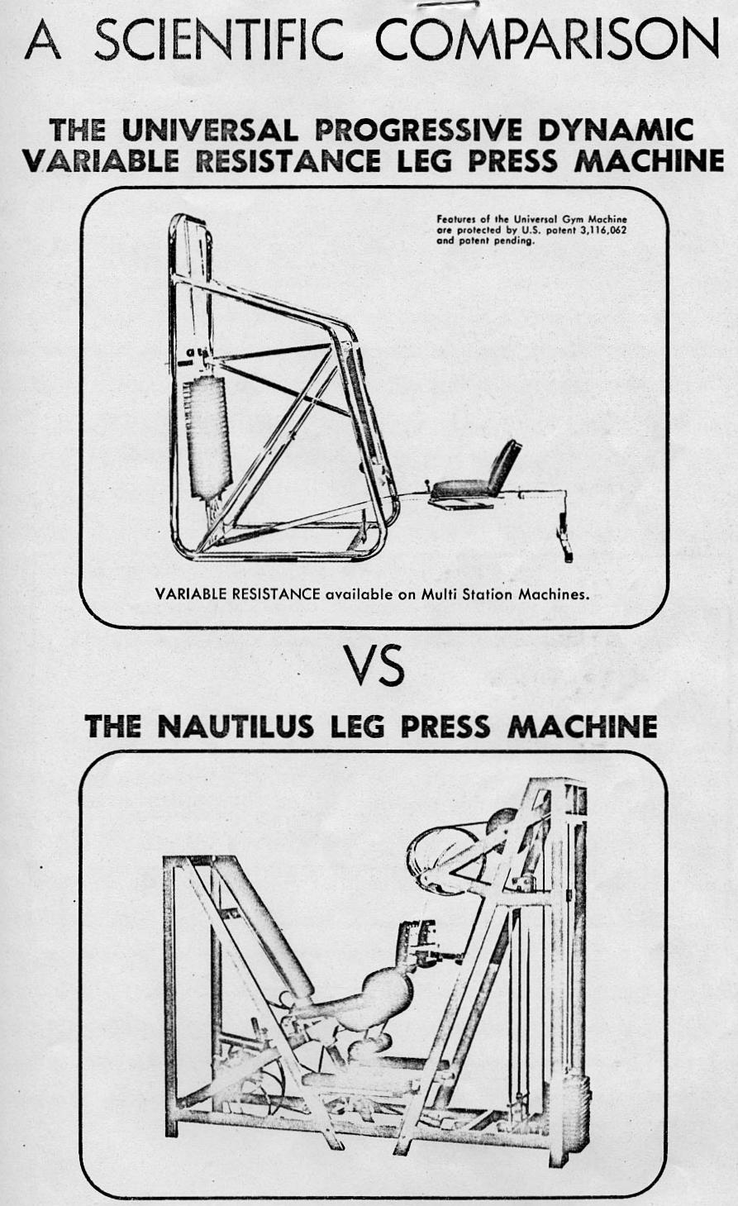
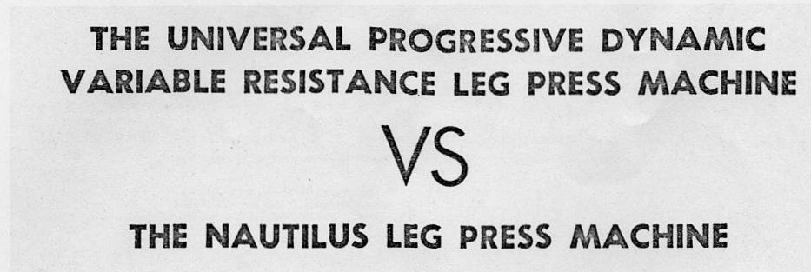
In order to scientifically evaluate these two leg press machines, it is necessary to define the standards which they should maintain.
It can be assumed that the leg press machine was originally developed in order to strengthen the leg extensors around the knee joint. In order to achieve this function, the ideal machine should provide for the following factors:
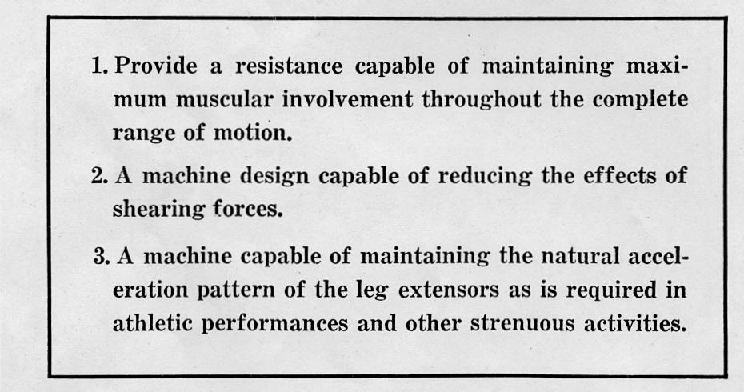
Actual computer outputs on the Nautilus leg press machine have been included along with a brief interpretation of their findings. (Universal computer outputs have been previously provided in an earlier publication, "Understanding the Scientific Bases Behind the Universal Centurion.
The following muscle force curve for the Nautilus leg press machine reveals that the resistance provided fails to maintain maximum muscular efforts throughout the entire range of movement. Maximum muscular efforts are required only in the initial phase of movement and then the required muscular efforts diminish rapidly to a point of less than 10% muscular involvement (or exertion).
On the other hand, Universal is capable of maintaining a muscle performance level above 90% throughout the range of motion. Observing Universal's muscular force curve, one can see that the muscular efforts vary only slightly throughout the range of movement and yet never fall below 90%. This results in a far superior conditioning benefit to the leg extensor muscles.
CONCLUSION: It is possible to assume that the failure to provide accurate variable resistance in the Nautilus leg press occurred as a result of their inability to accurately assess human movement and the other external motion parameters. Their lack of knowledge resulted in a machine incapable of accommodating the biomechanical changes necessary for maximum muscular performance. In addition, the mass of the machine's moving parts is capable of creating inertia forces which further reduce the required muscular efforts.
Universal, through accurately assessing man and machine, developed a far superior leg press machine resulting in near maximum muscular performance throughout the entire range of movement.
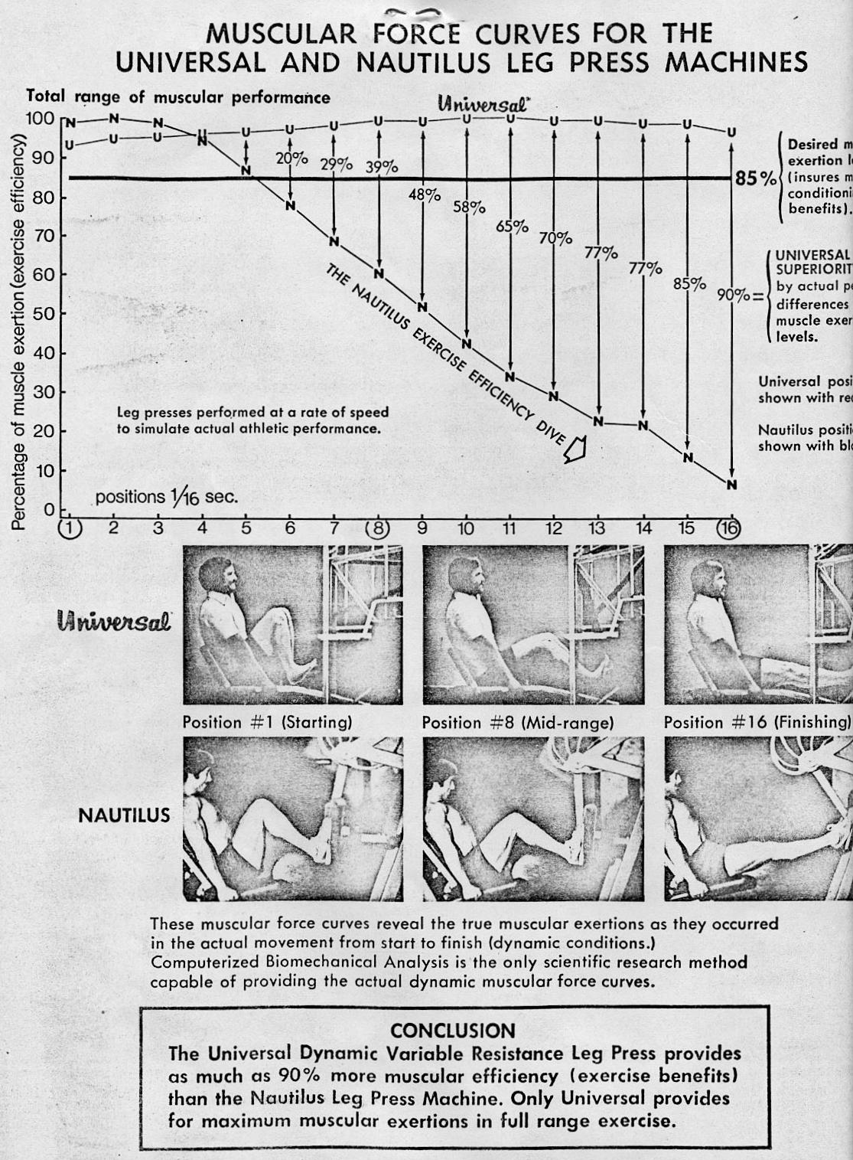
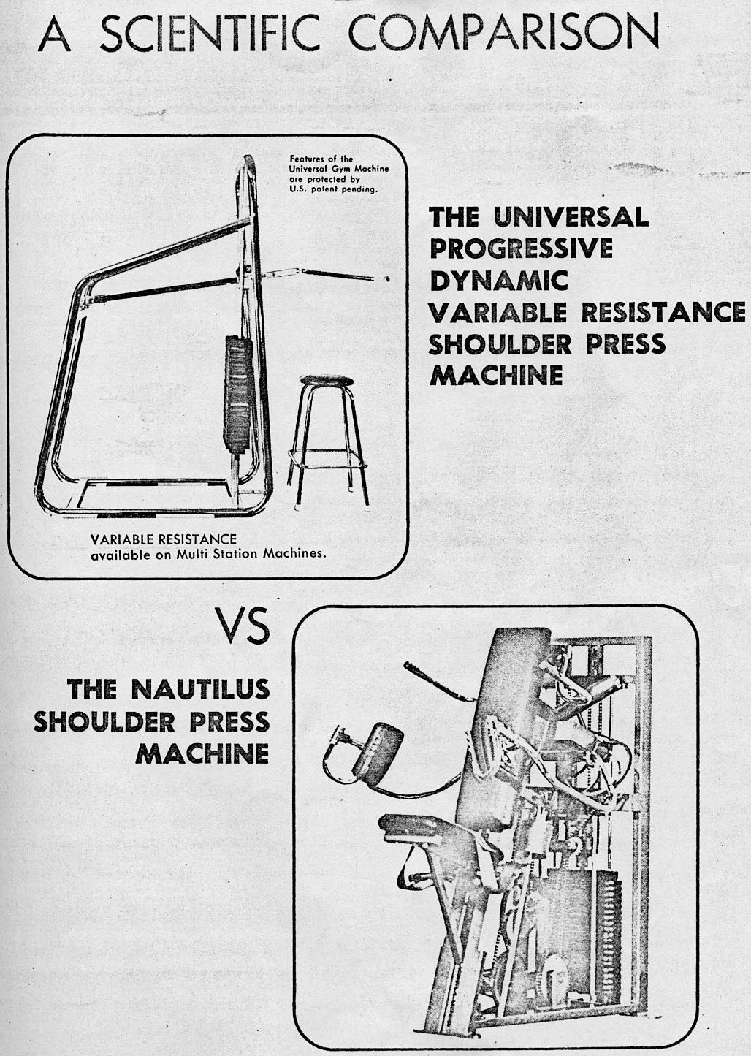

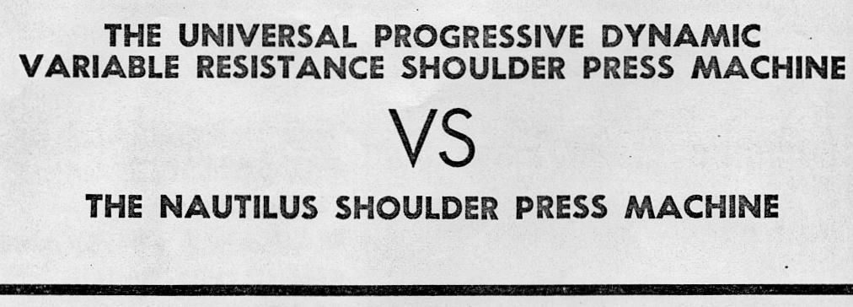
The following graph represents the moment (muscle force) curve which denotes the total muscular involvement in percentages as it occurred throughout the entire range of the exercise. Observing the Nautilus' force curve, it is revealed that the machine provides for only 30% muscular efforts from positions 1 through 10, which is nearly half of the entire exercise movement. From position 10 until completion of the stroke, the resistance increases which provides for greater muscular efforts.
The Universal shoulder press machine ensures more than 75% muscular involvement throughout the entire range of movement and over 90% muscular involvement for approximately two-thirds of the entire movement.
The exercise benefits, as revealed by the muscular force curves, indicate that the Nautilus shoulder press station has increasing resistance. However, the variation in their resistance is inaccurate in its intensity and occurs at the wrong time in the exercise stroke. The Nautilus cam profile has inaccurately dealt with the proper biomechanical requirements. Again, it is possible to assume that the conditioning deficiency in the Nautilus shoulder press is due to their inability to accurately assess the necessary biomechanical requirements for this particular exercise.
Universal, as a result of scientific research, developed a shoulder press machine which ensures maximum muscular performance throughout the range of movement. The result of Universal's efforts is the only shoulder press machine capable of providing maximum conditioning effectiveness.
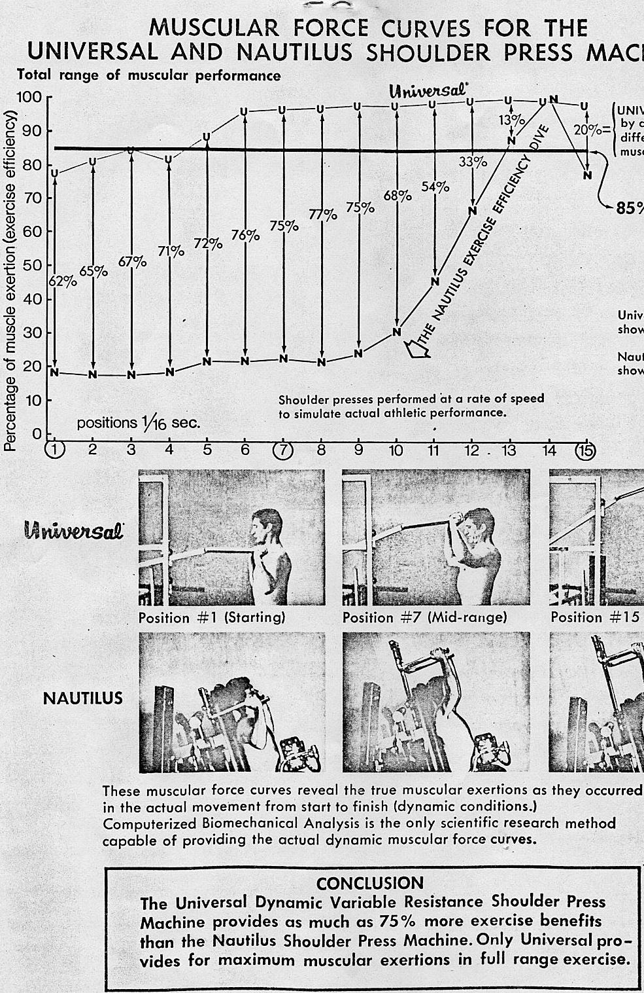
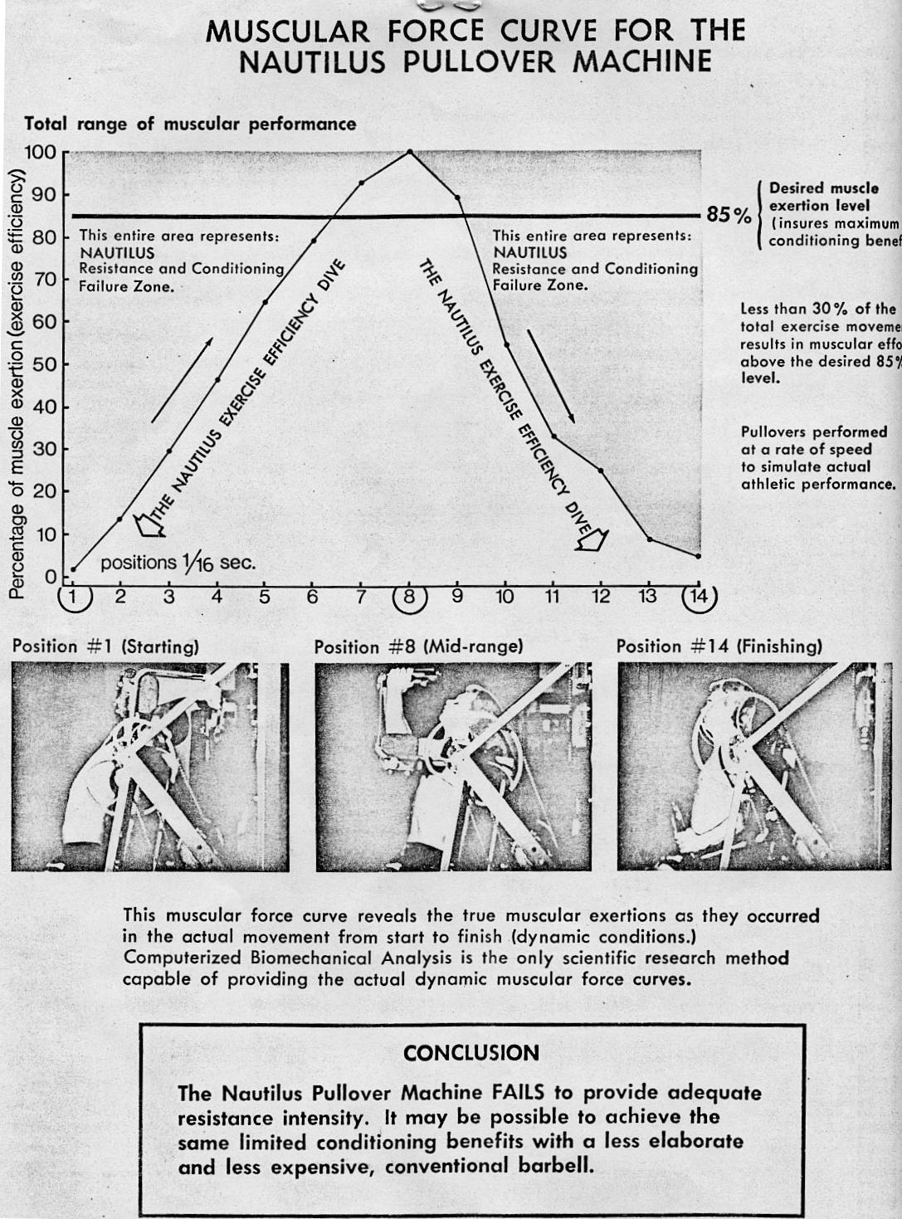
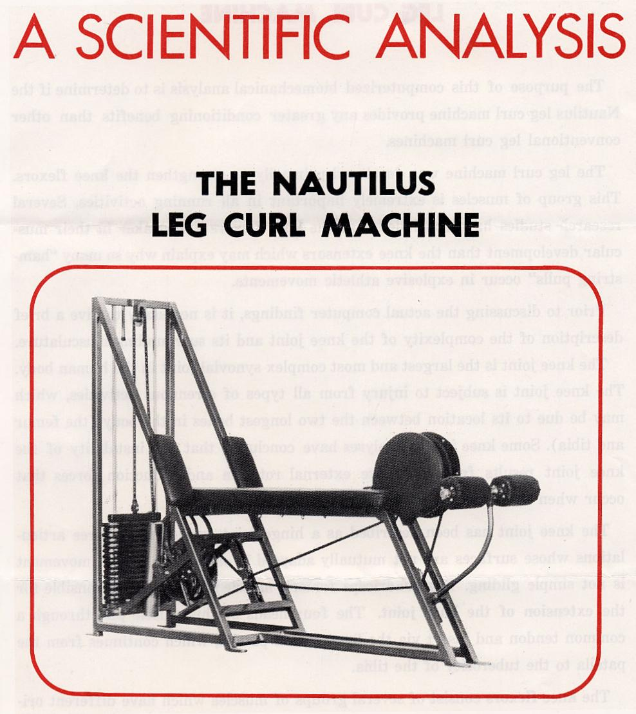
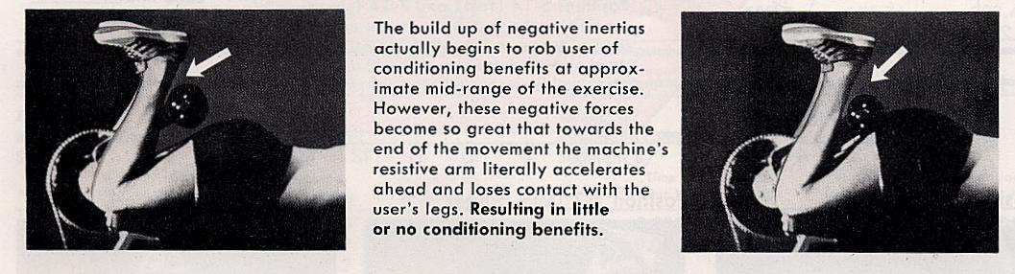
The Nautilus leg curl machine fails to accommodate the biomechanical changes which results in limited ranges of conditioning effectiveness (benefits). The machine's moving parts create adverse inertial forces robbing the user of additional conditioning benefits. It is possible to assume that the mechanical failures of this machine resulted from the lack of accurately assessing the biomechanical and motion parameters.
The only effective resistance is provided in the early stage of the movement (approximately 40% of total movement).
It may be possible to achieve the same conditioning effects on conventional leg curl machines.
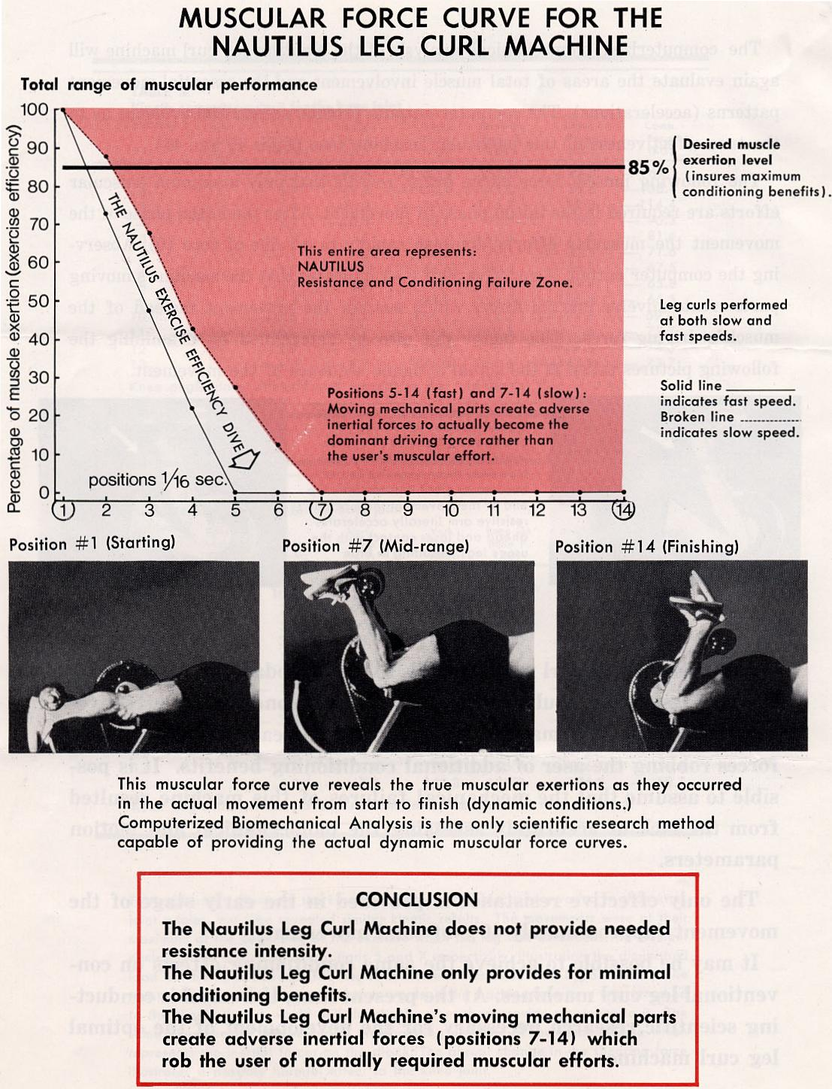
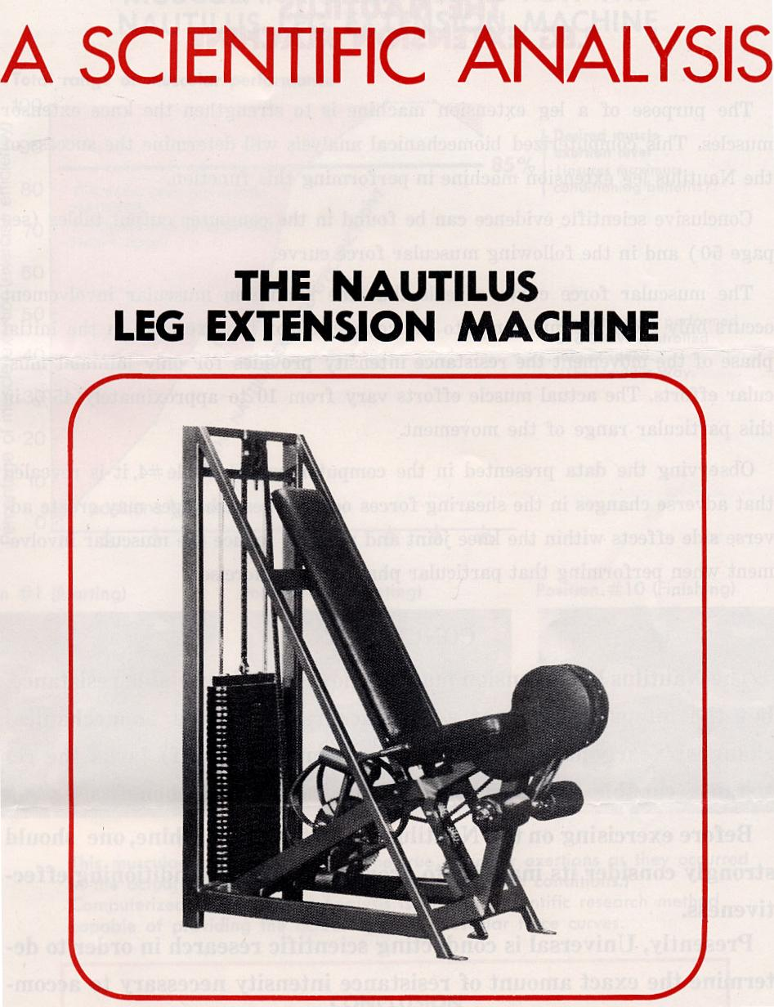
The Nautilus leg extension machine does provide variable resistance, but the intensity does not adjust accurately to the biomechanical changes! Nearly half of the total movement (first half) lacks the resistance capable of insuring maximum conditioning benefits.
Before exercising on the Nautilus leg extension machine, one should strongly consider its inability to provide maximum conditioning effectiveness.
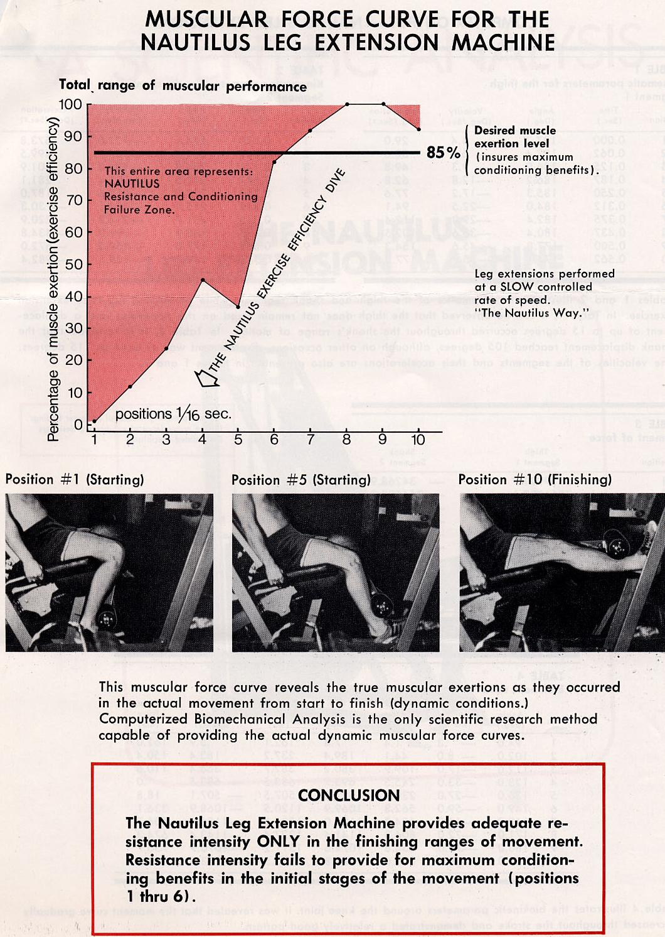
EVALUATION OF CONDITIONING PRINCIPLES & TERMS
The purpose of this chapter is to briefly discuss the differences between the Universal and Nautilus training principles and their relative conditioning effectiveness.
Presently, negative resistance training is advocated by Nautilus as a means of developing superior achievements in athletic strength. The following information will provide a realistic view of this newly-advocated method of conditioning.
NEGATIVE RESISTANCE TRAINING -
ANOTHER MISCONCEPTION IN ATHLETIC TRAINING
Negative resistance training is simply the exertion of maximum muscular efforts while lowering a weight from the extended or ending position back to its original starting position. The muscular activity that takes place during this reverse action is often referred to as eccentric or lengthening contraction. In this activity, the muscle contracts while merely returning from its shortened or fully contractile state to its normal resting length.
This is a natural muscular function that occurs when exercising; however, Nautilus is now advocating that greater emphasis be placed on this lowering or negative phase of movement rather than the actual lifting or positive phase of movement. Presently, there appears to be no scientific basis that training in a negative fashion will improve the degree of positive or FUNCTIONAL STRENGTH. Contrary to this belief, there are several factors that should be considered before training in this manner as a means of developing strength for athletic performances.
In previous chapters it was made clear that any resistance to a muscle may be beneficial to increase the muscular force; however, in athletics as well as other physical activities, the primary concern is the development of "FUNCTIONAL STRENGTH." FUNCTIONAL STRENGTH may be defined as the force variations in a particular displacement (direction). The ability to exert a maximum force at only one isolated joint angle has no bearing on the efficiency of human performance.
The characteristics of athletic FUNCTIONAL STRENGTH include the ability to instantaneously change the degree of speed, force, direction, and intensity. When exercising a muscle in a negative fashion, the motion or direction as well as the speed of movement is opposite to the required (positive) motion and develops a negative central pattern which may be detrimental to FUNCTIONAL STRENGTH. Negative training over a long period of time may further result in an impairment of coordination and a reduction in athletic ballistic efficiency (speed of the movement) as well as reductions in the biochemical activities within the muscle.
The first rule in any weight training program should be to train the muscle in a positive manner to insure a FUNCTIONAL STRENGTH.
The second rule in weight training is to TRAIN TO PERFORM. Every athletic activity has its own unique muscular demands. For example, some activities may require greater leg strength while other activities require greater arm strength. In addition, they also may differ in the direction in which the force is required. A high jumper requires vertical leg strength while a long jumper requires horizontal leg strength.
Due to these differences, it is essential that training routines develop FUNCTIONAL STRENGTH in a manner which closely simulates the desired activity. It would appear rather obvious that maximum athletic performances cannot be achieved through negative training as well as training all athletes under the same training program. The key to Universal's success has been superior resistive equipment and the ability to provide meaningful conditioning programs specifically to a sport.
THE UNIVERSAL PROGRESSIVE
DYNAMIC VARIABLE RESISTANCE
"The greatest technological advancement in resistive equipment.,
Only Universal has been able to accurately determine man's complete resistive
needs and successfully employ them into a failure-pioof oof lifting system. The natural lifting ratio is maintained while the resistive intensity instantaneously adjusts to accommodate the mechanical changes. This results in maximum muscular efforts throughout the entire range in motion.
All of this was corroborated by a third party evaluator. It seemed that the work that my team and I completed was scientifically sound, not that I had doubted it. But a third party had now confirmed it and this made it official. In fact, the Universal Marketing department immediately started to distribute this paper (which in truth was much more in depth but I don’t want to put you to sleep) around the world. Finally, the paper reached Jones from Nautilus.
When Jones got the “Green Brochure,” he begged us to take it off the market.
Which led to my next phone call from Harold Zinkin, the President of Universal, asking me to come as soon as possible to Fresno to his office.
“This is an emergency,” he said.
The next day I flew to Fresno from Hartford, Connecticut, the closest airport to Amherst.
Once again, we had an emergency meeting of Harold Zinkin, Chuck Cocker, Cliff Cocker, Ed Burke and the Universal attorneys. We all sat around Zinkin’s large conference table and there was an air of great victory about the Universal team.
The discussion covered Arthur Jones’ of Nautilus sudden proposal to settle the legal battle between the two companies. He was ready to compensate for damages and pay legal fees.
The next day at 2PM we met with Arthur Jones in Harold’s office. This time it was Harold and myself only. The two attorneys, one for Universal and one for Nautilus, waited outside.
I sat quietly at the table, not saying a word. I didn’t need to with these two extraverts. After a long discussion and various finger pointing by Harold and Arthur Jones, they came to some agreement.
The out of court settlement consisted of the following:
- Arthur Jones immediately would publish a retraction to his statement in the Athletic Journal.
- Arthur Jones would pay some cash (I prefer not to mention the amount but it was a 7 digit number).
- Payment to Harold would be separate from payment to me.
- In addition to the cash payment, Arthur would pay me an additional $200,000 in installments each month which we would call a consultation fee for movie making. That meant that Jones would produce some fitness movies and I would be one of the guests.
I really did not like number 4. But Harold convinced me that it would be good for both companies and to the outside world it would look as if the “War” between Universal and Nautilus had ended. Reluctantly, I agreed. At one point I asked Harold what about Ed, Cliff and Chuck. He told me that the damages were only felt by him and me. Therefore, it was supposed to be totally confidential. In fact, now is the first time I am revealing this agreement.
I will publish here the document that went with the agreement. Needless to say, that after 2 years or so, another episode occurred with Jones which started a new legal battle with him and his stopping the required payment to me. This comes later.
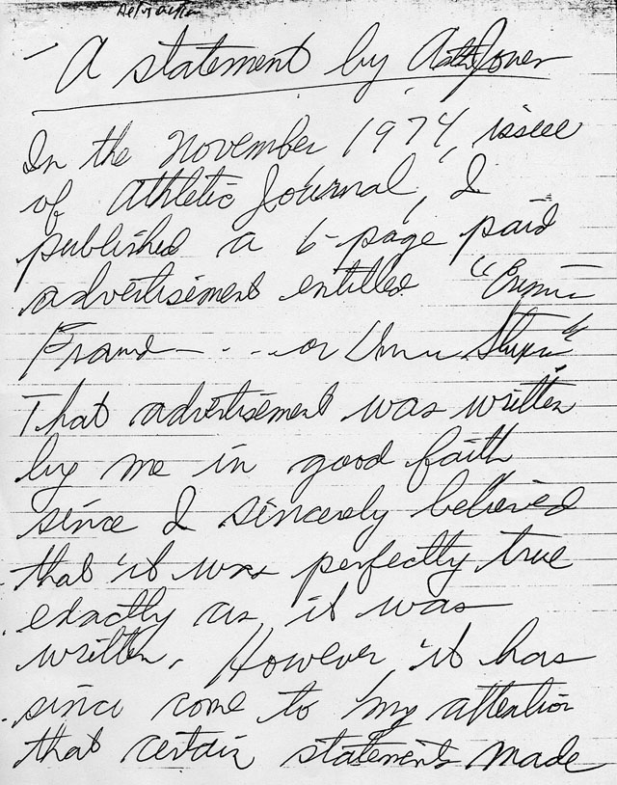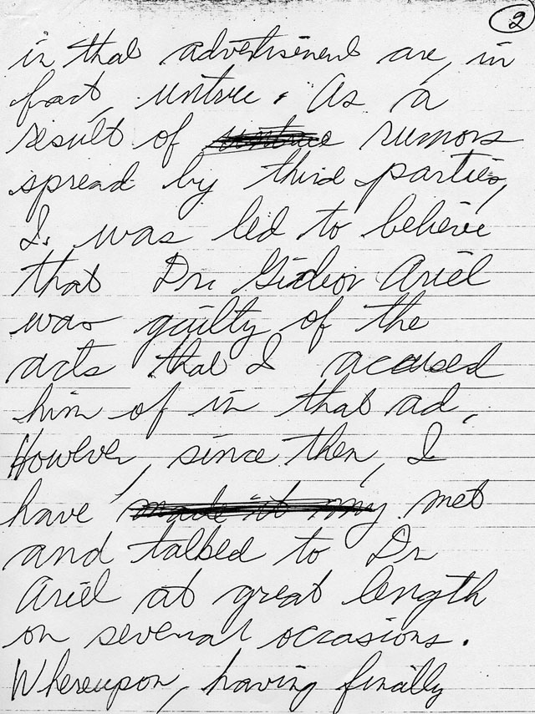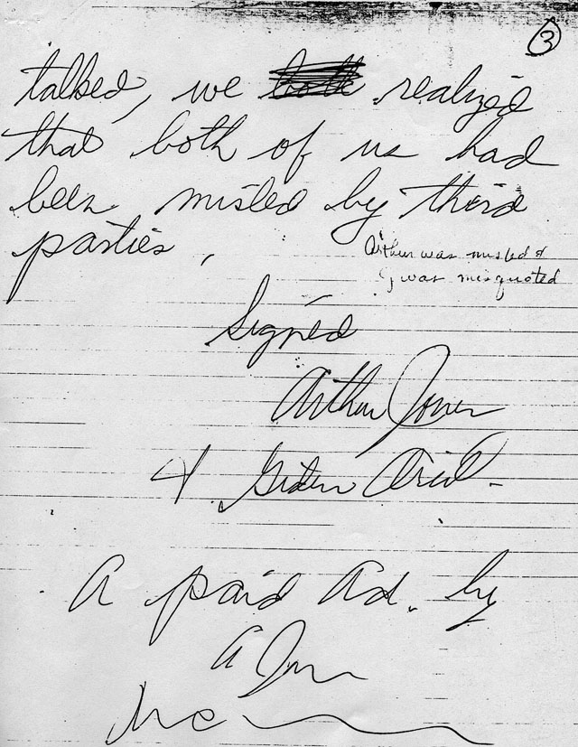
Arthur Jones retraction in his own hand writing.

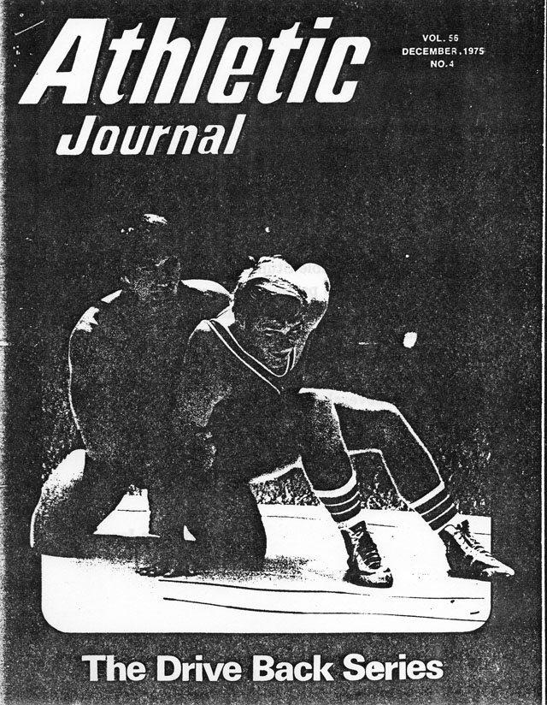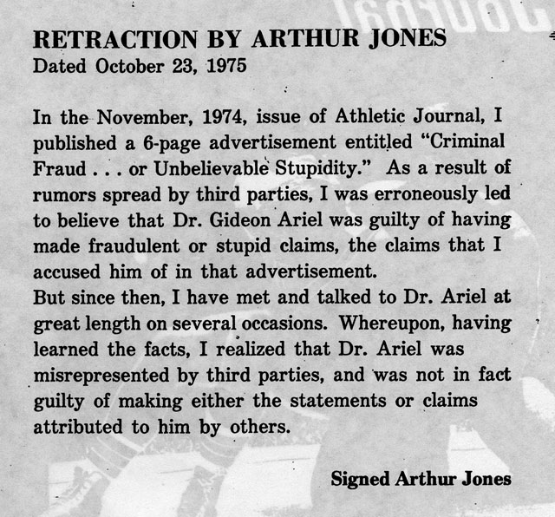

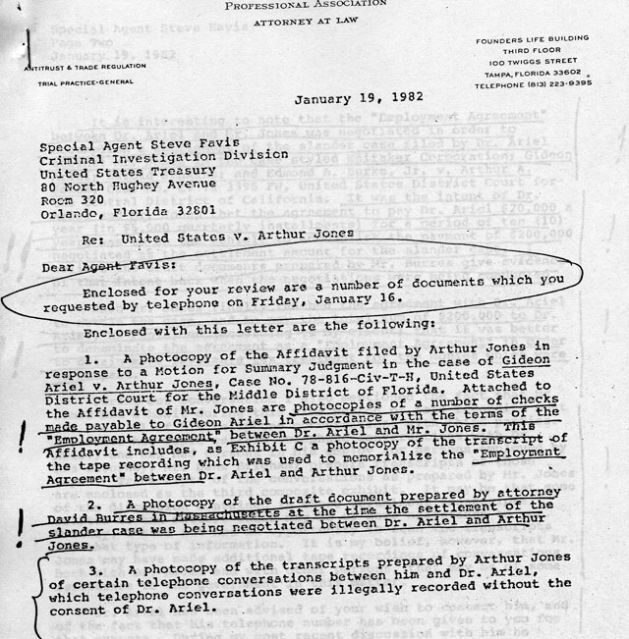
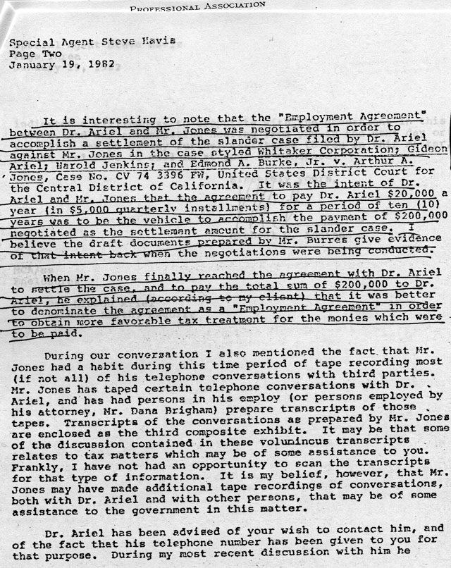
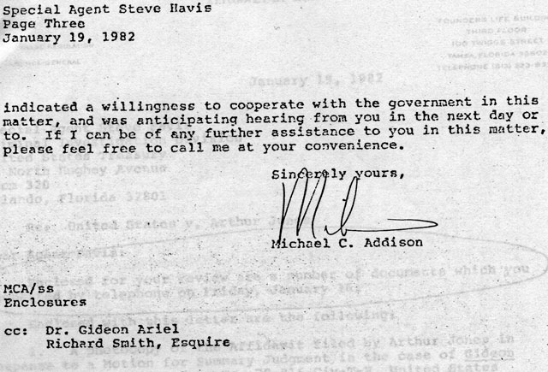
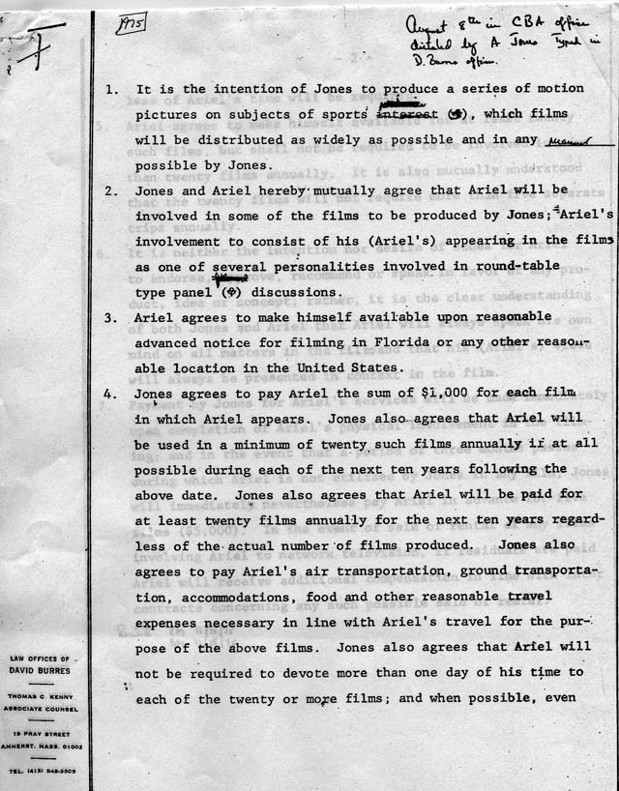
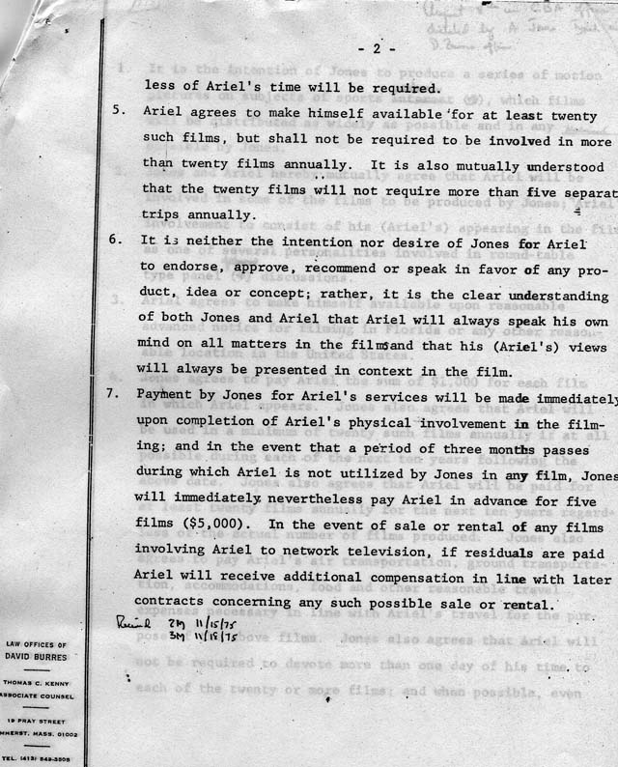

The war was over. Science always wins in the long run. Corporations and individuals will try to destroy innovative people who have new ideas. They do it because their own ideas are worn out but tried and true, even if they are no longer relevant or even no longer accurate. My exercise equipment and my motion analysis system won in the end. They are still the leader in the field today.

